**CS263-Web**

**Technology Lab**

**HTML**

**PANIDEM. VENKATA SAI KEERTHI**

**Y20CS133**

1. **a. Create a table to show your class timetable.**

**THEORY:**

HTML Table Tags



**SOURCE CODE**:

<!DOCTYPE html>

<html>

<head>

<title>time table</title>

<style>

h1{

text-align:center;

}

table,th,td{

width:1100px;

border: 1px solid black;

border-collapse:collapse;

}

th,td{

text-align:center;

padding:17px;

}

</style>

</head>

<body>

<h1>R.V.R & J.C COLLEGE OF ENGINEERING(AUTONOMOUS),GUNTUR-522019<br><br>

DEPARTMENT OF COMPUTER SCIENCE AND ENGINEERING<br><br>

TIME TABLE W.E.F.18-04-2022<br><br>

II/IV B.TECH(IV-SEMESTER)A.Y 2021-2022</h1>

<table >

<tr>

<th>DAY</th>

<th>8:00-9:00</th>

<th>9:00-10:00</th>

<th>10:00-11:00</th>

<th>11:00-12:00</th>

<th>12:00-1:00</th>

<th>1:00-2:00</th>

<th>2:00-3:00</th>

</tr>

<tr>

<th>MON</th>

<td colspan="3">WT LAB(C-III)</td>

<td rowspan="6">LUNCH</td>

<td>DBMS</td>

<td>OS</td>

<td>SPORTS</td>

</tr>

<tr>

<th>TUE</th>

<td>SE</td>

<td>E&HV</td>

<td>CS</td>

<td colspan="3">DBMS LAB(C-III)</td>

</tr>

<tr>

<th>WED</th>

<td>OS</td>

<td>DBMS</td>

<td>WT</td>

<td>SE</td>

<td>CS</td>

<td>LIBRARY</td>

</tr>

<tr>

<th>THUR</th>

<td>SE</td>

<td>OS</td>

<td>DBMS</td>

<td>SOC</td>

<td>CS</td>

<td>WT</td>

</tr>

<tr>

<th>FRI</th>

<td colspan="3">CS LAB(C-III)</td>

<td>CS</td>

<td>DBMS</td>

<td>WT</td>

</tr>

<tr>

<th>SAT</th>

<td colspan="2">SOC LAB(C-III)</td>

<td>WT</td>

<td>E&HV</td>

<td colspan="2">COMPETITIVE CODING(E-LE)</td>

</tr>

</table>

</body>

</html>

**OUTPUT:**

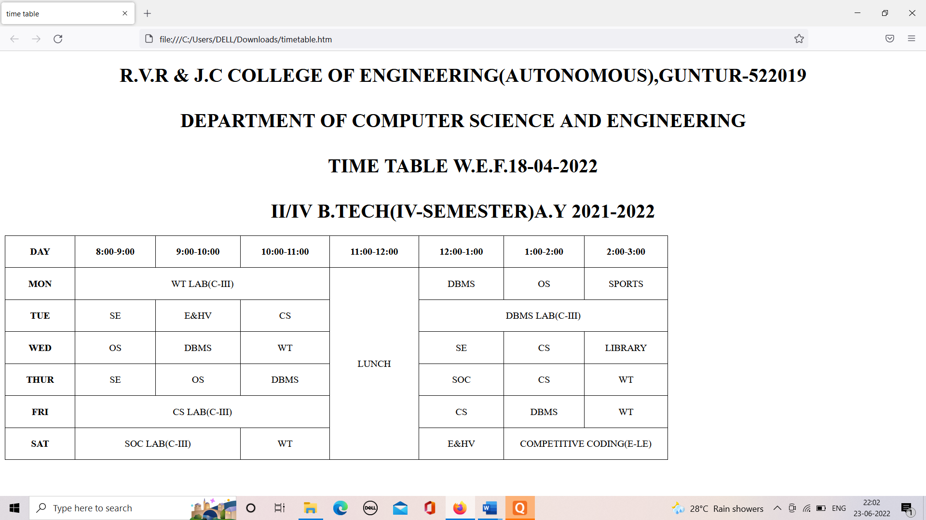

**b. Use tables to provide layout to your HTML page describing your college infrastructure.**

**THEORY:**

* HTML tables can adjust the padding inside the cells, and also the space between the cells.
* Cell padding is the space between the cell edges and the cell content.
* By default the padding is set to 0.
* To add padding on table cells, use the CSS padding property
* To add padding only above the content, use the padding-top property.
* And the others sides with the padding-bottom, padding-left, and padding-right properties
* Cell spacing is the space between each cell.
* By default the space is set to 2 pixels.
* To change the space between table cells, use the CSS border-spacing property on the table element
* HTML tables can have cells that spans over multiple rows and/or columns.
* The value of the colspan attribute represents the number of columns to span.
* The value of the rowspan attribute represents the number of rows to span.

**SOURCE CODE:**

<!DOCTYPE html>

<html>

<head>

<title>college infrastructure</title>

</head>

<style>

body {

background-color:pink;

}

table,th,td{

border:none;

}

</style>

<body>

<h1 style="text-align:center;"> R.V.R. & J.C. COLLEGE OF ENGINEERING INFRASTRUCTURE </h1>

<table>

<h3>The Infrastructure</h3>

<tr>

<td>spread</td>

<td>:</td>

<td>37.41Acres</td>

</tr>

</table>

<table>

<h3>Built-up area:</h3>

<tr>

<td>R.C.C.</td>

<td>:</td>

<td>75504 Sq.m.</td>

</tr>

<tr>

<td>Non-R.C.C.</td>

<td>:</td>

<td>9951 Sq.m.</td>

</tr>

</table>

<table>

<h3>Hostels:</h3>

<tr>

<td>Boys</td>

<td>:</td>

<td>19080 Sq.m.</td>

</tr>

<tr>

<td>Girls</td>

<td>:</td>

<td>10617 Sq.m.</td>

</tr>

</table>

<table>

<h3>Building details</h3>

<tr>

<td>Lecture Halls</td>

<td>:</td>

<td>94</td>

</tr>

<tr>

<td>Drawing Halls</td>

<td>:</td>

<td>15</td>

</tr>

<tr>

<td>Engineering/Science Labs</td>

<td>:</td>

<td>71</td>

</tr>

<tr>

<td>Computer Centers</td>

<td>:</td>

<td>15</td>

</tr>

<tr>

<td>A/C Seminar Halls</td>

<td>:</td>

<td>04</td>

</tr>

</table>

<table>

<h3>Amenities</h3>

<tr>

<td>Auditorium</td>

<td>:</td>

<td>01</td>

</tr>

<tr>

<td>Open-air Theatre</td>

<td>:</td>

<td>01</td>

</tr>

<tr>

<td>Transport Fleet</td>

<td>:</td>

<td>29 buses</td>

</tr>

<tr>

<td>Canteen,Snack bar & Dining Rooms</td>

<td>:</td>

<td>01</td>

</tr>

<tr>

<td>Mineral Water Plant</td>

<td>:</td>

<td>01</td>

</tr>

<tr>

<td>Bank</td>

<td>:</td>

<td>01</td>

</tr>

<tr>

<td>Play Fields, Sports facilities & Gymnasia</td>

</tr>

<tr>

<td>NCC and NSS Units</td>

</tr>

<tr>

<td>Hobby Clubs</td>

</tr>

<tr>

<td>Boys and Girls Common rooms</td>

</tr>

<tr>

<td>Rain Water Storage Dam</td>

</tr>

</table>

<table>

<h3> Library</h3>

<tr>

<td>Area</td>

<td>:</td>

<td>1766 Sq.mt.</td>

</tr>

<tr>

<td>Volumes</td>

<td>:</td>

<td>1,04,018</td>

</tr>

<tr>

<td>Titles</td>

<td>:</td>

<td>29,165</td>

</tr>

<tr>

<td>Journals</td>

<td>:</td>

<td>114</td>

</tr>

<tr>

<td>Internet / Intranet access</td>

</tr>

<tr>

<td>Computerized Services</td>

</tr>

<tr>

<td>INDEST Membership</td>

</tr>

<tr>

<td>Qualified Library Staff</td>

<td>:</td>

<td>07</td>

</tr>

</table>

</body>

</html>

**OUTPUT:**

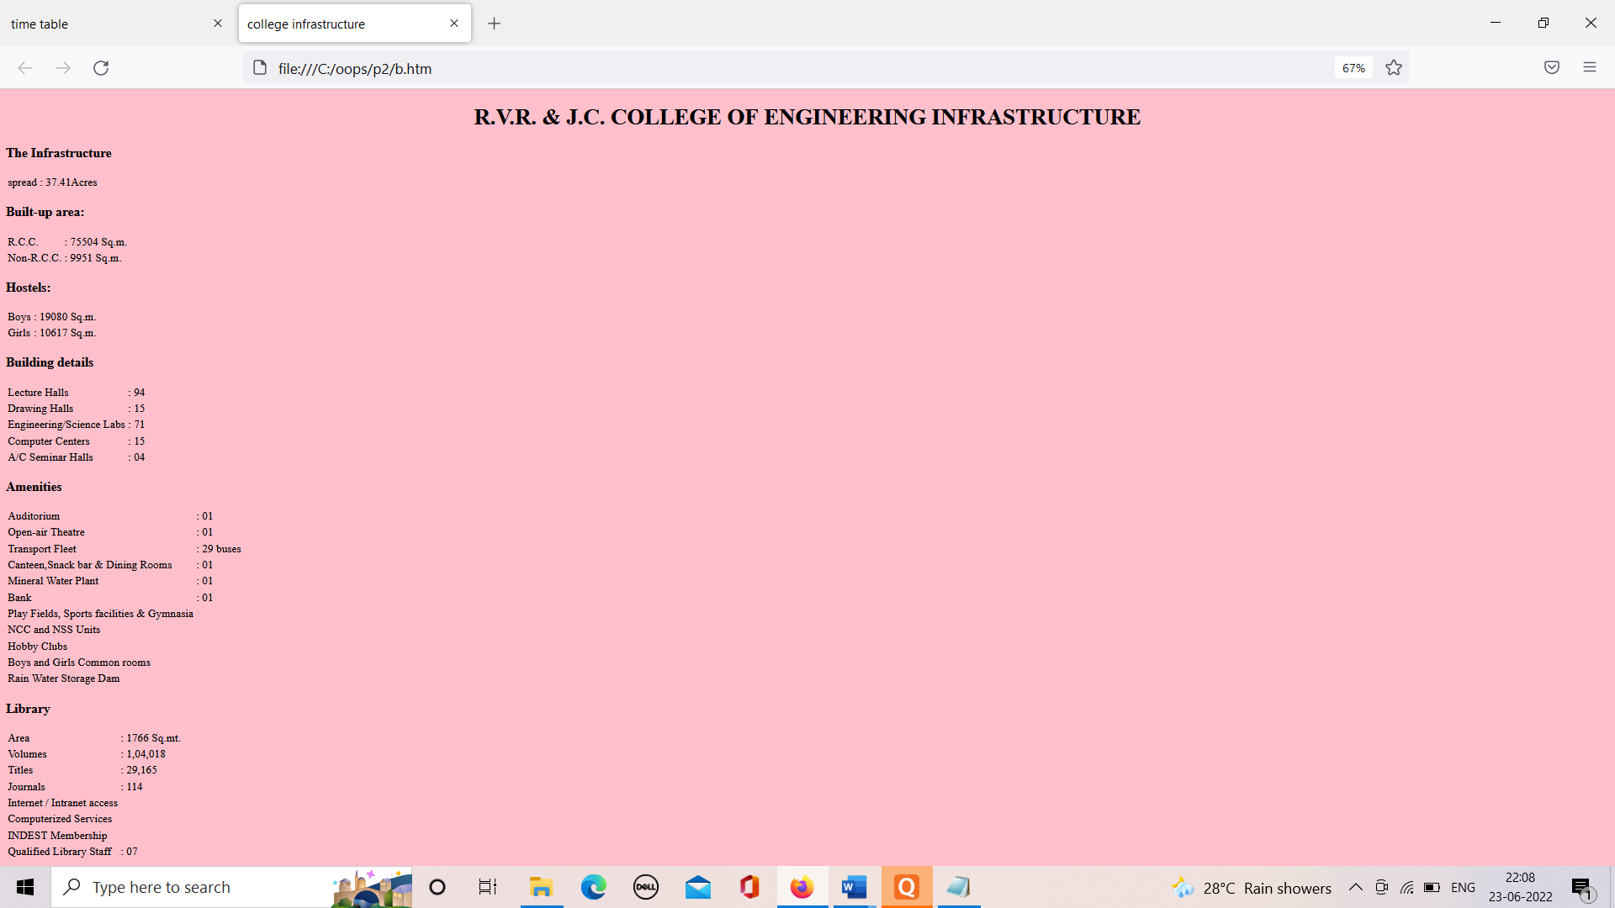

**c. Use <span> and <div> tags to provide a layout to the above page instead of a table layout.**

**THEORY:**

* The <div> tag defines a division or a section in an HTML document.
* The <div> tag is used as a container for HTML elements - which is then styled with CSS or manipulated with JavaScript.
* The <div> tag is easily styled by using the class or id attribute.
* Any sort of content can be put inside the <div> tag!
* The <span> tag is an inline container used to mark up a part of a text, or a part of a document.
* The <span> tag is easily styled by CSS or manipulated with JavaScript using the class or id attribute.
* The <span> tag is much like the [<div>](https://www.w3schools.com/tags/tag_div.asp) element, but <div> is a block-level element and <span> is an inline element.

**SOURCE CODE:**

<!DOCTYPE html>

<html>

<head>

<title>DIV, SPAN</title>

</head>

<style>

body {

background-color:Teal;

}

</style>

<body>

<div style = "width:100%">

<div>

<h1><center>R.V.R. & J.C. COLLEGE OF ENGINEERING INFRASTRUCTURE </center></h1>

</div>

<div>

<div><b>The Infrastructure</b></div>

</div>

<div>

<p>Spread</p>

<div>

<div>

<p>37.41 Acres</p>

</div>

</div>

</div>

<div>

<div><b>Build-up Area</b></div>

</div>

<div >

<p>R.C.C</p>

</div>

<div>

<p>75504 Sq.m.</p>

</div>

<div >

<p>Non R.C.C</p>

</div>

<div>

<p>9951 Sq.m</p>

</div>

<div>

<div><b>Hostels</b></div>

</div>

<div >

<p>Boys</p>

</div>

<div>

<p>19080 Sq.m.</p>

</div>

<div>

<p>Girls</p>

</div>

<div>

<p>10617 Sq.m</p>

</div>

</div>

<div >

<div><b>Building details</b></div>

</div>

<div>

<p>Lecture halls</p>

</div>

<div>

<p>94</p>

</div>

<div>

<p>Drawing halls</p>

</div>

<p>15</p>

</div>

<div>

<p>Engineering/Science Labs</p>

</div>

<div>

<p>71</p>

</div>

<div>

<p>Computer centres</p>

</div>

<div >

<p>15</p>

</div>

<div>

<p>A/c seminar halls</p>

</div>

<div>

<p>04></p>

</div>

</div>

<div>

<div><b>Amenities</b></div>

</div>

<div >

<p>Auditorium</p>

<div>

<p>01</p>

</div>

<div>

<p>Open-Air Theatre</p>

<div>

<p>01</p>

</div>

<div>

<p>Transport Fleet</p>

<div>

<p>29 buses</p>

</div>

<div>

<p>Canteen</p>

<div>

<p>01</p>

</div>

<div>

<p>Bank</p>

<div>

<p>01</p>

</div>

<div>

<p>Mineral water plant</p>

<div>

<p>01</p>

</div>

</div>

</div>

</div>

</div>

</div>

</div>

<div>

<p>Play Fields& Gymnasia</p>

</div>

<div>

<p>NCC and NSS units</p>

</div>

<div>

<p>Hobby Clubs</p>

</div>

<div>

<p>Boys and Girls Common rooms</p>

</div>

<div>

<p>Rain Water Storage Dam</p>

</div>

<div>

<div><b>Library</b></div>

</div>

<div>

<p>Area</p>

<div>

<p>1766 Sq.mt</p>

</div>

<div>

<p>Volume</p>

<div>

<p>1,04,018</p>

</div>

<div>

<p>Titles</p>

<div>

<p>29,165</p>

</div>

<div>

<p>Journals</p>

<div>

<p>114</p>

</div>

</div>

</div>

</div>

</div>

</div>

</div>

<div>

<p>Internet/Intranet access</p>

</div>

<div >

<p>Computerized Services</p>

</div>

<div>

<p>INDEST Membership</p>

</div>

<div>

<p>Qualified Library staff</p>

<div>

<div>07</div>

</div>

</div>

</div>

</div>

</body>

**OUTPUT:**

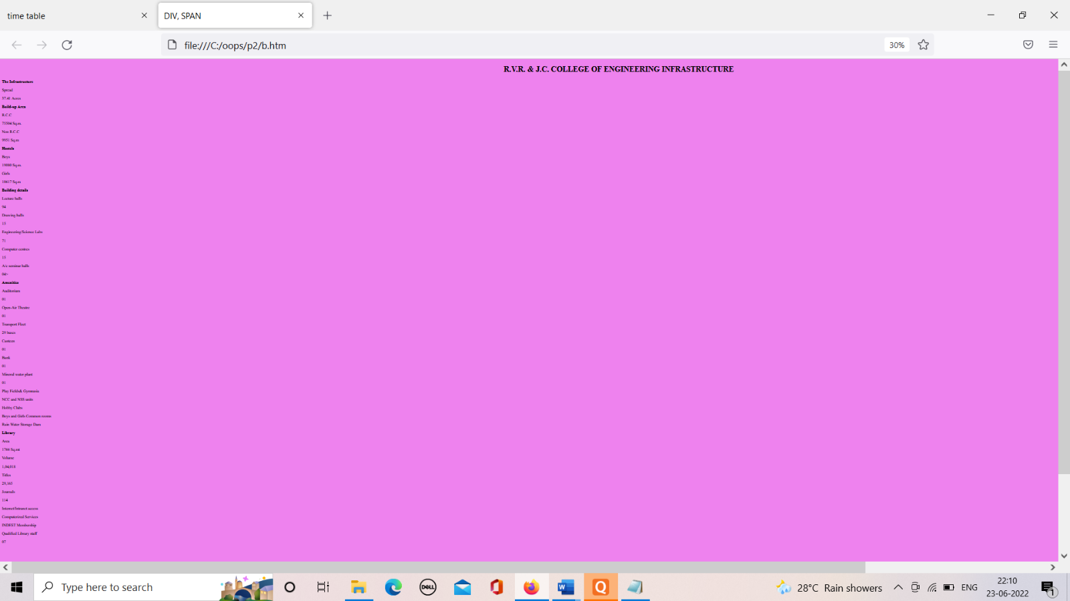

1. **a. Use frames such that page is divided into 3 frames 20% on left to show contents of pages, 60% in center to show body of page, remaining on right to show remarks.**

**THEORY:**

HTML frames are used to divide your browser window into multiple sections where each section can load a separate HTML document. A collection of frames in the browser window is known as a frameset. The window is divided into frames in a similar way the tables are organized: into rows and columns.

**SOURCE CODE**:

<!DOCTYPE html>

<html>

<head>

<title>

2a

</title>

</head>

<frameset cols="20%,60%,20%">

<frame name="left" src="data.htm">

<frame name="center" src="http://courses.rvrjcce.ac.in/moodle/login/index.php">

<frame name="right" src="remarks.htm">

<noframes>

<body>

Your browser does not support frames

</body>

</noframes>

</frameset>

</html>

<form>

remarks:<br>

<textarea rows="5" cols="30" name="remarks" spellcheck="true">

enter remarks here

</textarea>

<button >submit</button>

</form>

<h1>COURSES</h1>

<a href="stylesheet" src="">CSE</a><br>

<a href="stylesheet" src="">IT</a><br>

<a href="stylesheet" src="">CSBS</a><br>

<a href="stylesheet" src="">ECE</a><br>

<a href="stylesheet" src="">EEE</a><br>

<a href="stylesheet" src="">CIVIL</a><br>

<a href="stylesheet" src="">MECHANICAL</a>

**OUTPUT:**

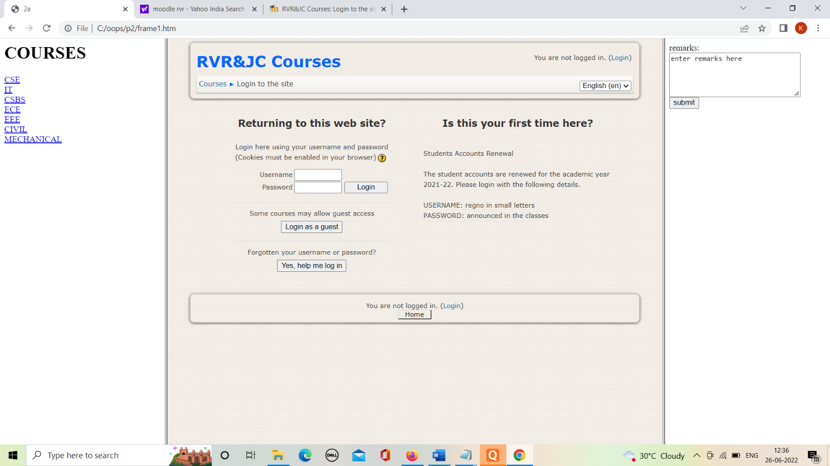

**b. Embed Audio and Video into your HTML web page.**

**THEORY:**

Audio:

* The controls attribute adds audio controls, like play, pause, and volume.
* The <source> element allows you to specify alternative audio files which the browser may choose from. The browser will use the first recognized format.
* The text between the <audio> and </audio> tags will only be displayed in browsers that do not support the <audio> element.

Video:

* The controls attribute adds video controls, like play, pause, and volume.
* It is a good idea to always include width and height attributes. If height and width are not set, the page might flicker while the video loads.
* The <source> element allows you to specify alternative video files which the browser may choose from. The browser will use the first recognized format.
* The text between the <video> and </video> tags will only be displayed in browsers that do not support the <video> element.

**SOURCE CODE:**

<!DOCTYPE html>

<html>

<body>

<audio src="C:\Users\DELL\Downloads\[iSongs.info] 03 - Sirivennela.mp3" controls>

</audio>

<video width="700" height="700" src="C:\Users\DELL\Downloads\keerthi.mp4" controls></video>

</body>

</html>

**OUTPUT:**

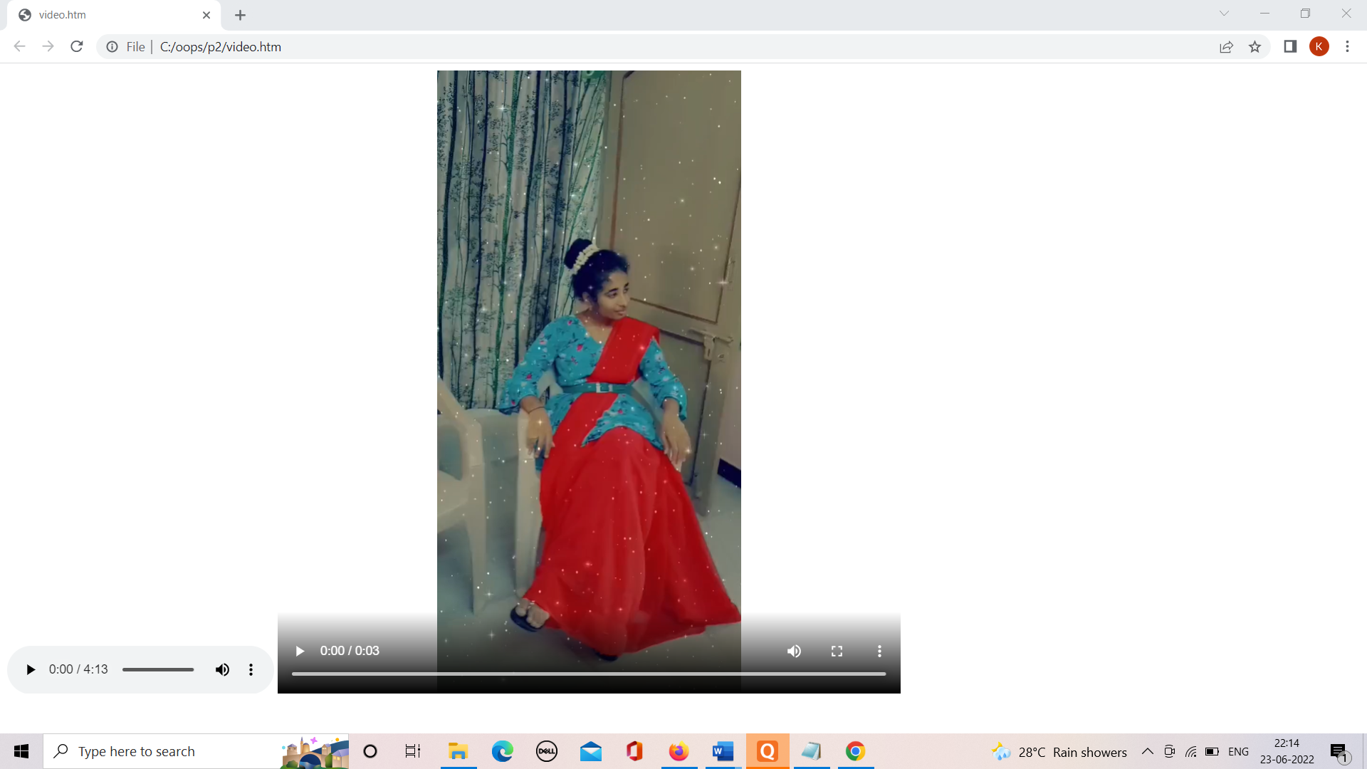

1. **a. Create a webpage with HTML describing your department use paragraph and list tags.**

**THEORY:**

* The HTML <p> element defines a paragraph.
* A paragraph always starts on a new line, and browsers automatically add some white space (a margin) before and after a paragraph.

HTML List Tags

## 

**SOURCE CODE:**

<!DOCTYPE>

<html>

<body style="background-color:pink;">

<center><h1 style="color:blue;">CSE DEPARTMENT PROFILE</h1></center>

<ul>

<li>The R.V.R. & J.C. College of Engineering introduced the undergraduate program in Computer Science & Engineering (CSE) in 1994. Since its inception, the department has grown exponentially in the areas of student intake, quality of academic work and student achievements. The initial student enrollment was 30. Since then, the B.Tech programme has seen a gradual increase in the student enrollment, and current annual intake stands at 180. Taking the needs of the academic institutions and the industry into cognizance, the department of CSE started M.Tech programme in the year 2003. The current annual intake for the M.Tech programme is 18. This programme helps to enhance the quality of the academic atmosphere in the department.</li>

<li>The department has excellent infrastructure to support the teaching learning process. More than half of the class rooms of the department have the integrated computer-assisted teaching systems. The faculty of the department utilizes these systems to deliver lectures effectively. A new training facility named E-class room was developed in the year 2009. The E-class room is one of a kind training facility capable of hosting 75 participants at a time and has one dedicated computer terminal for each participant. The latest equipment required for video conferencing and remote lecture delivery are available in the E-class room. The department of CSE also maintains the MOODLE, the learning management system for electronic distribution of lecture material, online references and question papers. The learning management system, MOODLE is also being used by the faculty members to conduct online examinations.</li>

<li>The department has modern laboratories to serve the teaching and research needs of the students and faculty members. The laboratories of the department have substantial computing resources that include the latest hardware and software. The laboratories are equipped with the computers of latest configuration procured from MNCs. All the laboratory computers are connected to the campus network using hi-speed Fiber Optic Local Area Network. A dedicated leased line provides round-the clock Internet access to all the laboratory computers. The department also maintains a dedicated lab for improving the communication skills of the students.</li>

<li>The college and the department are well served by the central library. The central library has more than 5000 titles related to Computer Science and Engineering discipline. The central library has online subscription to various e-journals and INDEST (Indian National Digital Library in Engineering Science and Technology) consortium. The subscription provides online access to reputed engineering journals from professional societies like IEEE, ASME, ASCE, SPRINGER, ELSEVIER etc. There is also a dedicated department library to serve the needs of the department.</li>

</ul>

<p>The department is well supported in academics by qualified and experienced faculty including six doctorates. The faculty members of the department actively pursue research in their respective areas and publish research papers in renowned journals. The students are encouraged to participate in national and international conferences, workshops, student symposiums and to publish papers in national / international journals.</p>

<p>The department strives towards delivering quality education to the students. This fact is attested to by the National Board of Accreditation (NBA). The department of CSE received accreditation from NBA for 5 times during 2002, 2007, 2012, 2017 and 2021. The department invites experts from premiere educational institutions and the industry to conduct seminars / workshops on the advanced topics in Computer Science.</p>

<h2 style="color:blue;">Vision & mission</h2>

<dl>

<dt>To prepare graduates with</dt>

<dd>$ Sound knowledge of Computer Science and Engineering to solve real world problems.</dd>

<dt>To produce globally competent engineers to cater to the challenging computing needs of the society.</dt>

<dd>$ Adequate skills and behavior to exhibit code of conduct in their professional practice.</dd>

</dl>

</body>

</html>

**OUTPUT:**

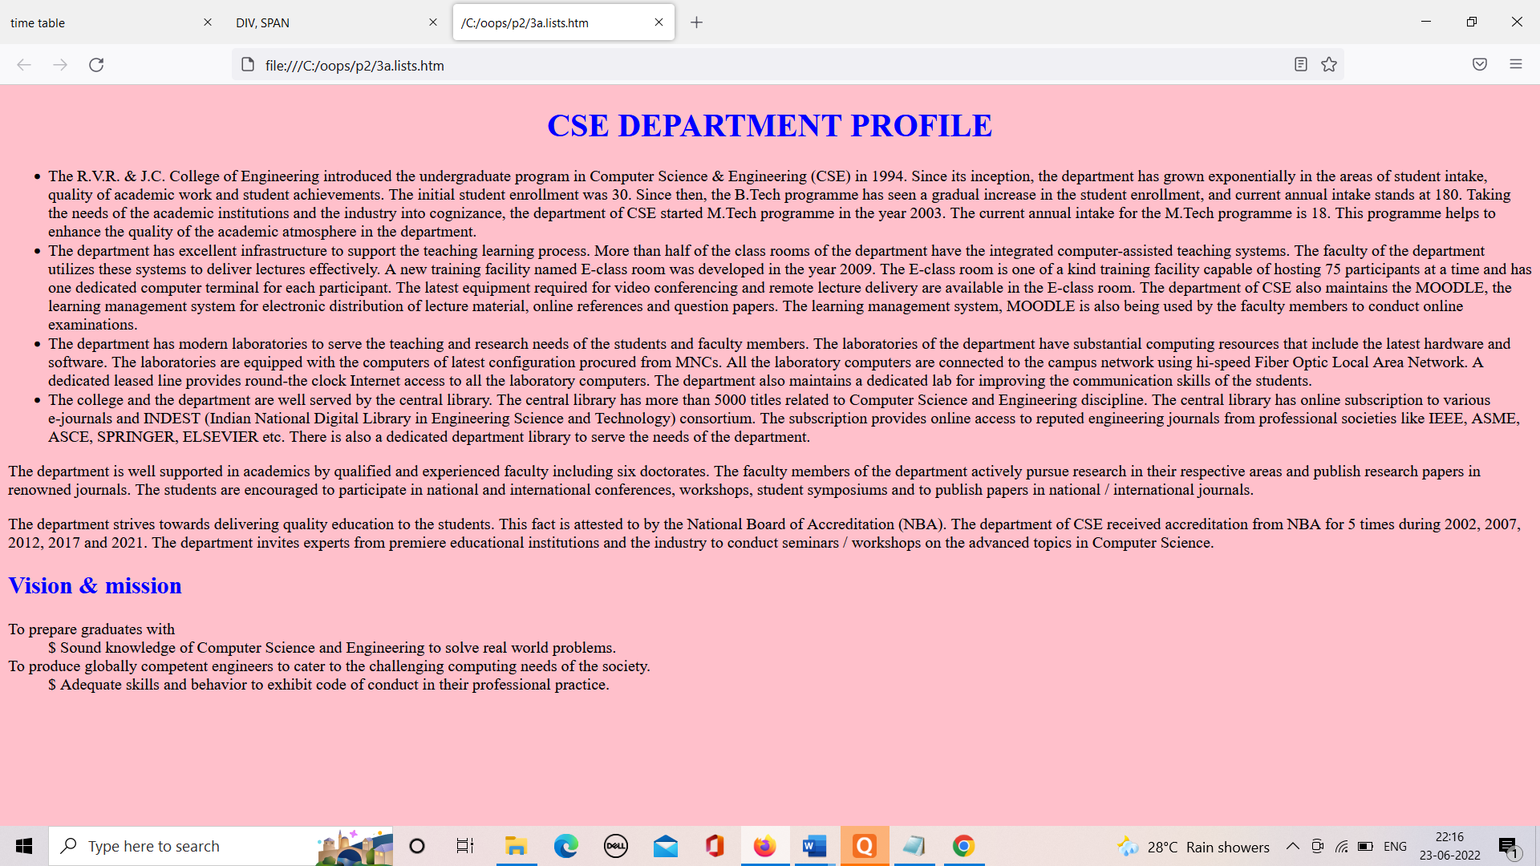

**b. Apply various colors to suitably distinguish key words, also apply font styling like italics, underline and two other fonts to words you find appropriate, also use header tags.**

**THEORY:**

* <b> - Bold text
* <strong> - Important text
* <i> - Italic text
* <em> - Emphasized text
* <mark> - Marked text
* <small> - Smaller text
* <del> - Deleted text
* <ins> - Inserted text
* <sub> - Subscript text
* <sup> - Superscript text

**SOURCE CODE:**

<html>

</head>

<body style="background-color:cyan;">

<center><p style="color:blue;"><b>text in bold</b><br><i>text in italic<i><strong>text in strong</strong><br>

<em>text is emphasized</em><br><small>text is small</small><br>

<mark>text is marked</mark><br><del>delete</del><br>

<ins>ins text</ins><sub>subscript</sub>

<sup>superscript</sup></p>

<p style="background-color:pink;">next text is in quotes:<q>this is keerthi</q></p>

<h1 style="background-color:DodgerBlue;">keerthi</h1>

<h2 style="background-color:Orange;">mahesh</h2>

<h3 style="color:tomato;">ajitha</h3>

<h4 style="color:MediumSeaGreen;">pujitha</h4>

<h5 style="border:2px solid Gray;">manasa</h5>

<h6 style="border:2px solid SlateBlue;">yash</h6>

</center>

</body>

</html>

**OUTPUT:**

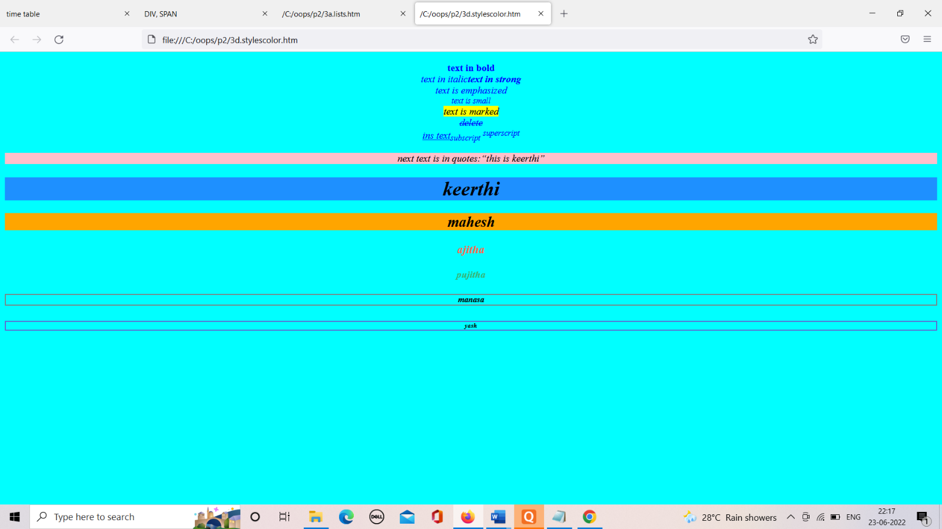

**c. Create links on the words e.g. ―Wi-Fi and ―LAN‖ to link them to Wikipedia pages.**

**THEORY:**

* HTML links are hyperlinks.
* You can click on a link and jump to another document.
* When you move the mouse over a link, the mouse arrow will turn into a little hand.

**SOURCE CODE:**

Wikipedia pages.

<!doctype html>

<html>

<head>

<meta charset = "utf-8" />

<title>keerthi</title>

</head>

<body>

<center><a style="font-size:160%;"href=https://en.wikipedia.org/wiki/Main_Page"title="WI-FI">Wi-fi</a></center>

<center><a style="font-size:160%;"href=https://en.wikipedia.org/wiki/Local_area_network"title="LAN">LAN</a></center>

</body>

</html>

**OUTPUT:**

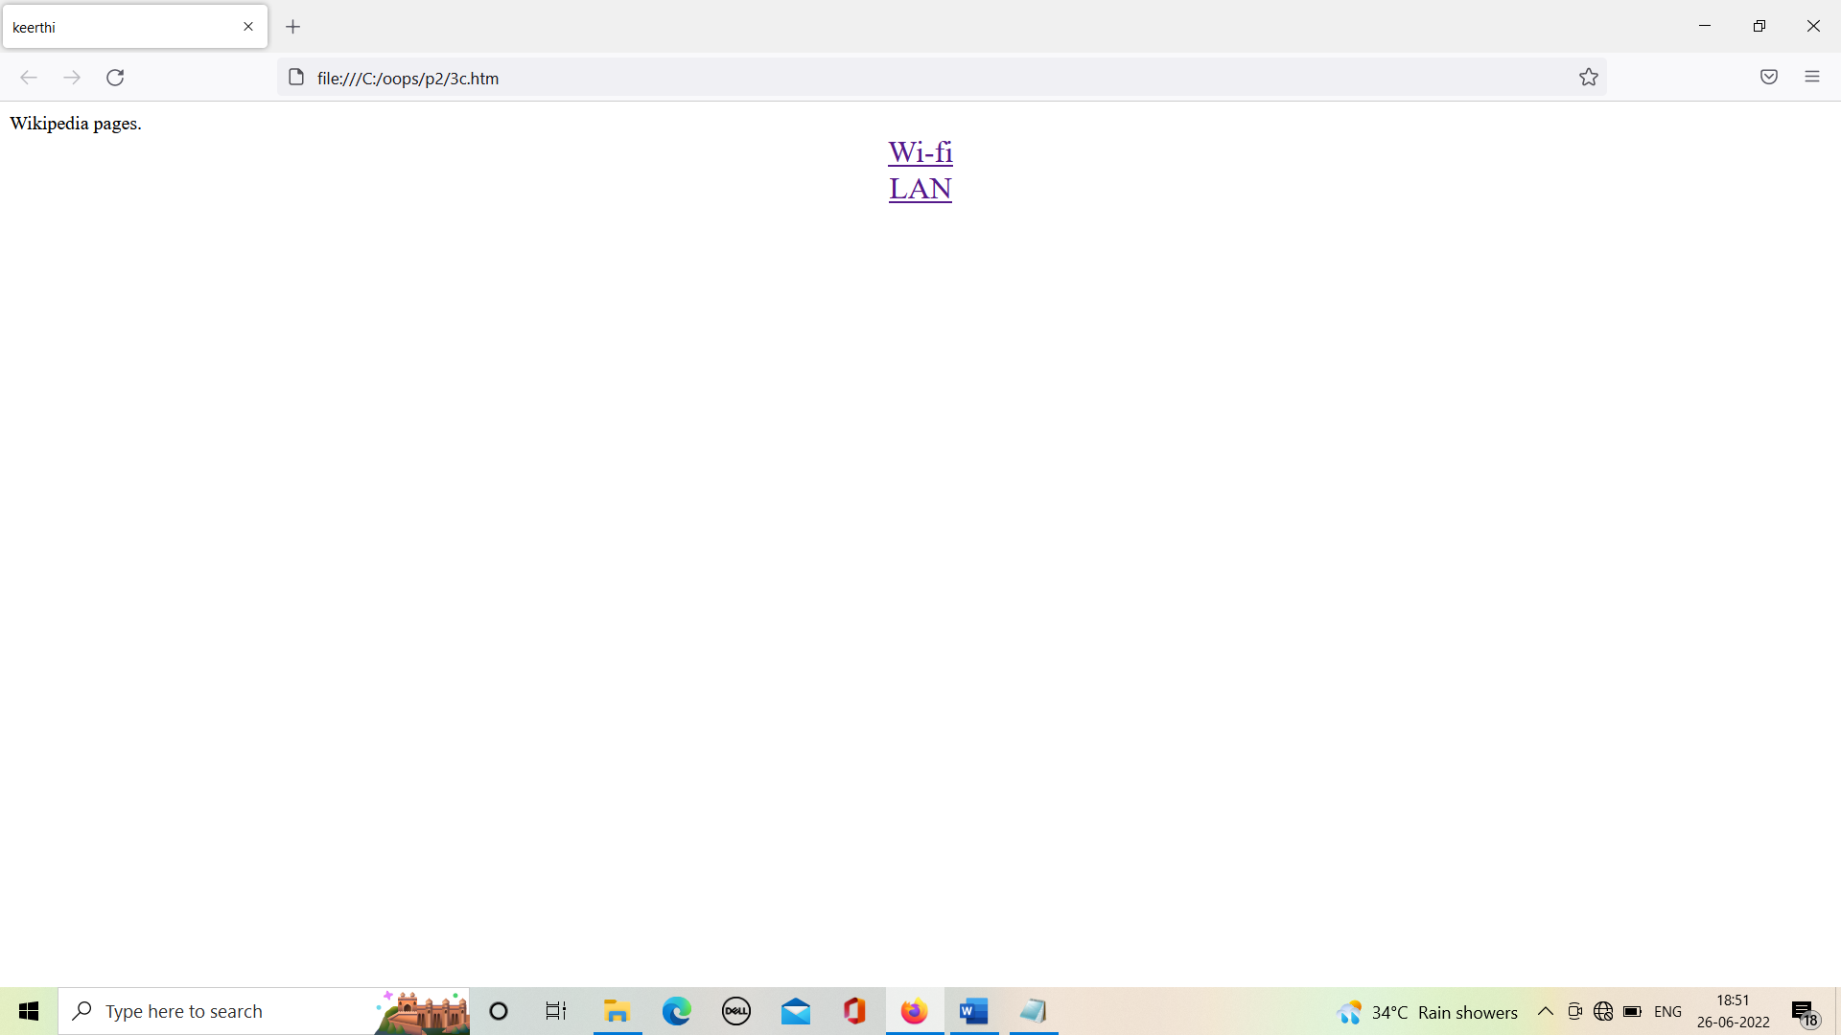

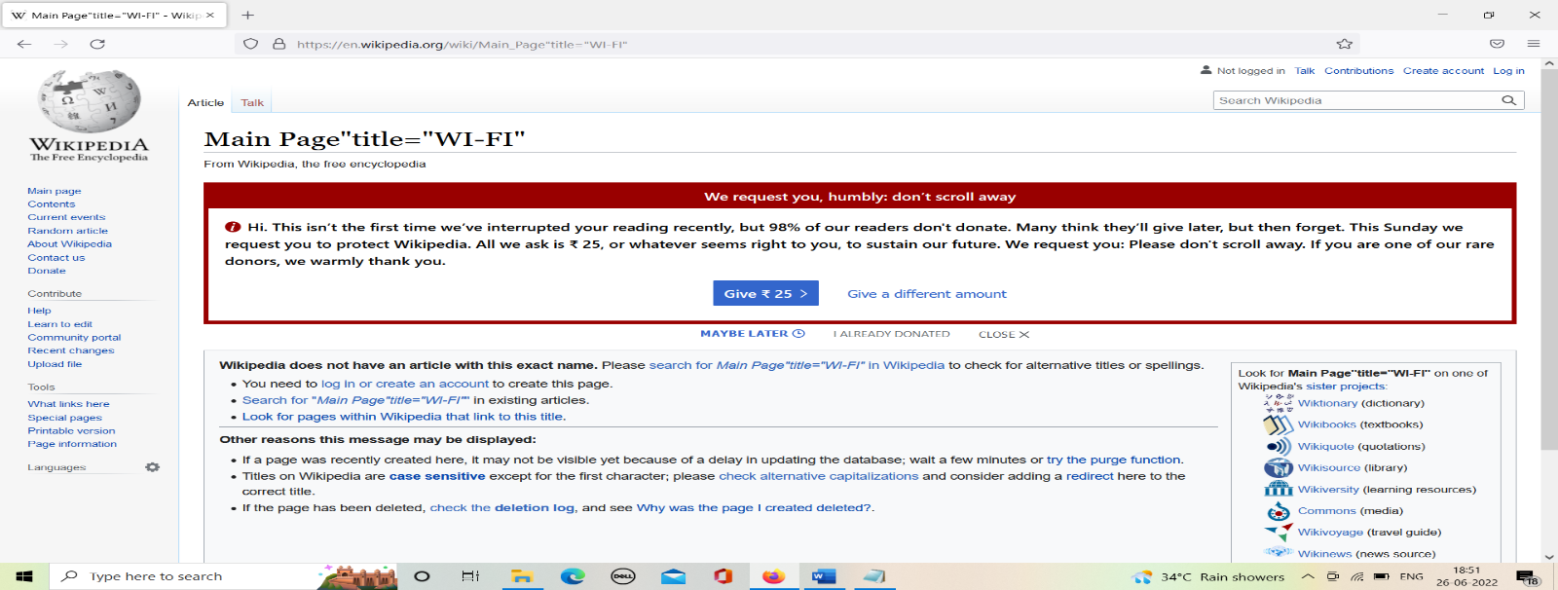

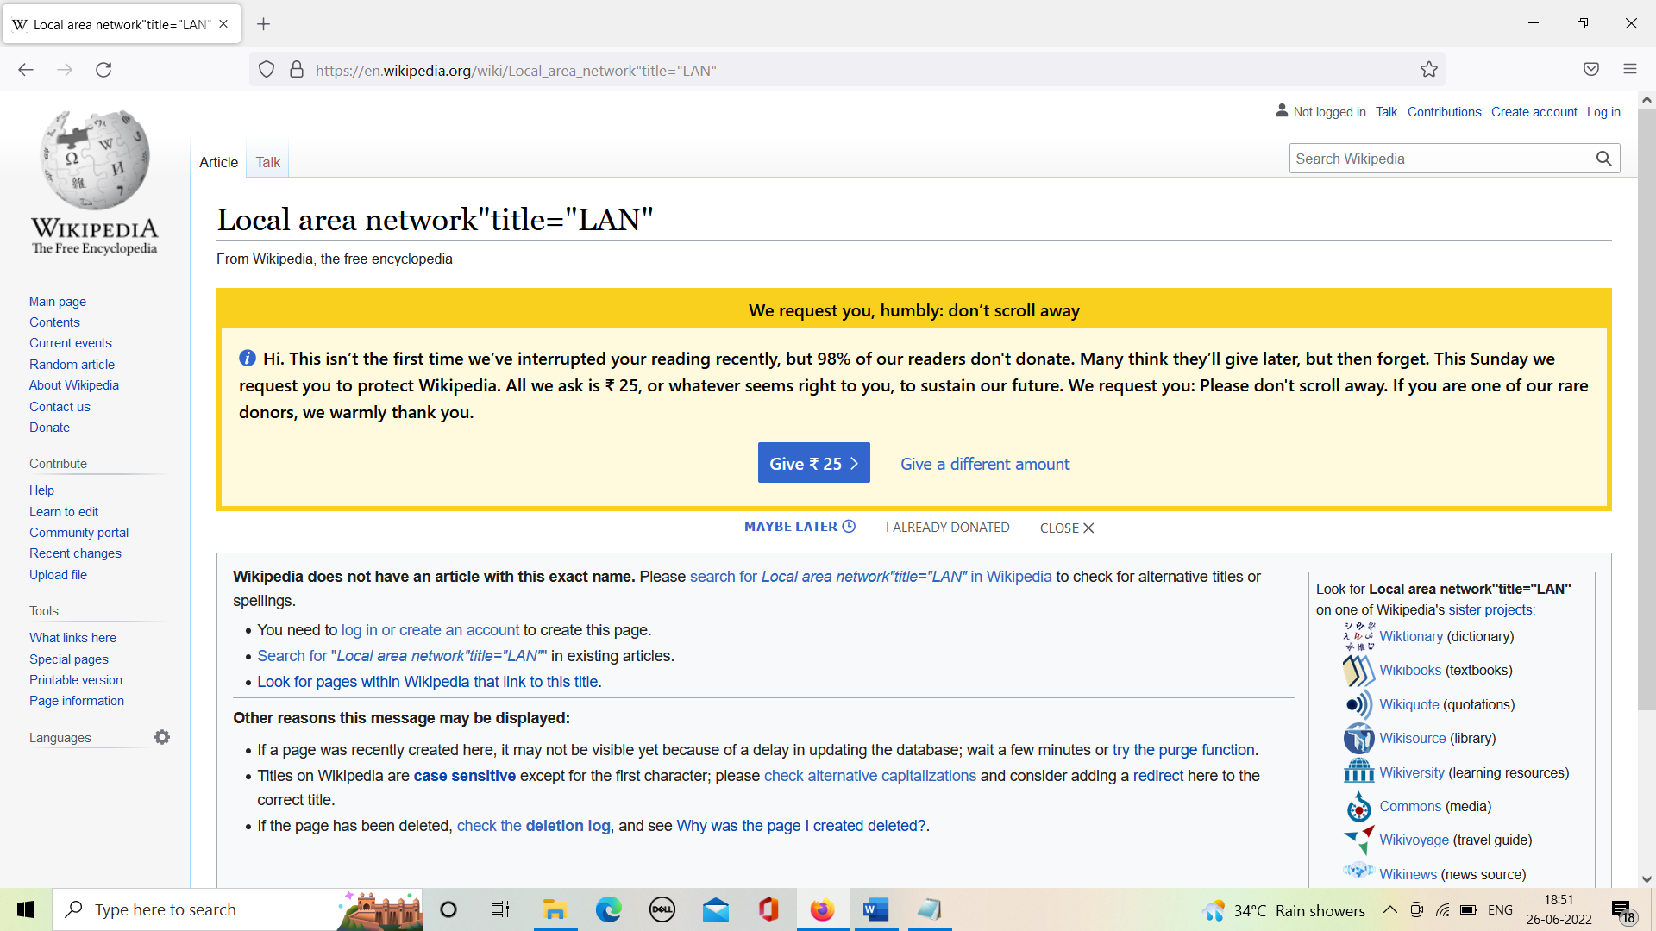

**d. Insert an image and create a link such that clicking on image takes user to other page.**

**THEORY:**

To use image as a link in HTML, use the <img> tag as well as the <a> tag with the href attribute. The <img> tag is for using an image in a web page and the <a> tag is for adding a link. Under the image tag src attribute, add the URL of the image. With that, also add the height and width.

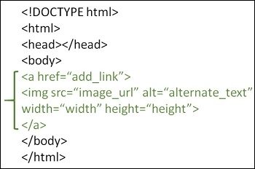

**SOURCE CODE:**

<html>

<head>

<title>hacker rank</title>

</head>

<body>

<center> <a href = "https://www.hackerrank.com/" target = "_blank">

<img src ="https://tse1.mm.bing.net/th?id=OIP.aiEgvLjGCcSQTDnU42f8SAHaHa&pid=Api&P=0&w=174&h=174" alt = "Tutorials Point" border = "0"/>

</a>

</center>

</body>

</html>

**OUTPUT:**

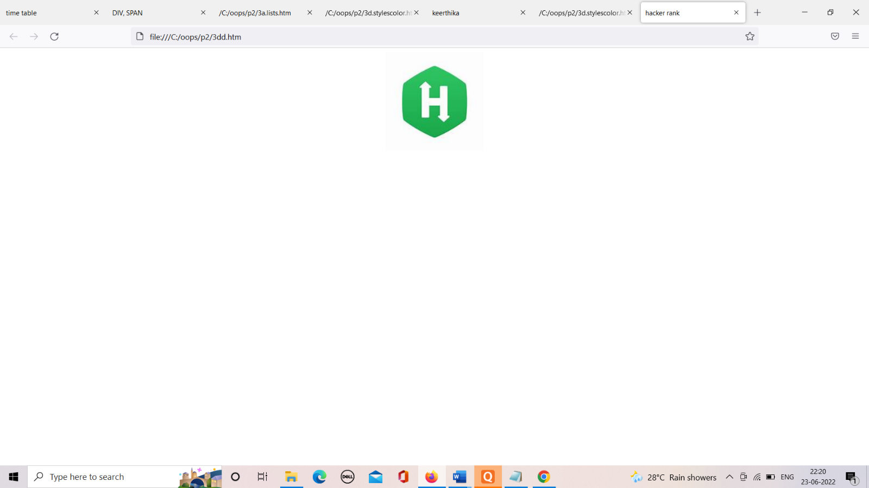



**e. Change the background color of the page; at the bottom create a link to take user to the top of the page.**

**THEORY:**

* To create a link that goes to the top of a web page, follow the steps below.
* In your HTML code, find the opening <body> tag (this should be located right after the closing </head> tag). Immediately after the opening <body> tag, add the following code.
* <a name="top"></a>
* The code above creates an anchor on the page named top.
* Next, add the top of page link using the # symbol and "top" anchor name/id as the value of the href attribute, as shown below.
* <a href="#top">Back to top of page</a>
* If you scrolled down on this page, clicking this link takes you back to the top of the page.

**SOURCE CODE:**

<!DOCTYPE html>

<html>

<head>

<title>

3

</title>

</head>

<body style="background-color:blanchedalmond;">

<h1>R.V.R. & J.C. COLLEGE OF ENGINEERING</h1>

<p style="color:blue;"> CSE DEPARTMENT </p>

<ol>

<li>The <strong>R.V.R. & J.C. College of Engineering</strong> introduced the undergraduate program in <b>Computer Science & Engineering (CSE)</b> in 1994. Since its inception,

the department has grown exponentially in the areas of student intake, quality of academic work and student achievements. The initial student enrollment was 30.

Since then, the B.Tech programme has seen a gradual increase in the student enrollment, and current annual intake stands at 180. Taking the needs of the academic

institutions and the industry into cognizance, the department of CSE started M.Tech programme in the year 2003. The current annual intake for the M.Tech programme is 18.

This programme helps to enhance the quality of the academic atmosphere in the department.</li>

<li>The department has <i>excellent infrastructure</i> to support the teaching learning process. More than half of the class rooms of the department have the integrated

computer-assisted teaching systems. The faculty of the department utilizes these systems to deliver lectures effectively. A new training facility named E-class room

was developed in the year 2009. The E-class room is one of a kind training facility capable of hosting 75 participants at a time and has one dedicated computer terminal

for each participant. The latest equipment required for video conferencing and remote lecture delivery are available in the E-class room. The department of CSE also

maintains the MOODLE, the learning management system for electronic distribution of lecture material, online references and question papers.</li>

<li>The department has modern laboratories to serve the teaching and research needs of the students and faculty members. The laboratories of the department have substantial

computing resources that include the latest hardware and software. The laboratories are equipped with the computers of latest configuration procured from MNCs.

All the laboratory computers are connected to the campus network using hi-speed Fiber Optic Local Area Network. A dedicated leased line provides round-the clock Internet

access to all the laboratory computers. The department also maintains a dedicated lab for improving the communication skills of the students.</li>

<li>The college and the department are well served by the central library. The central library has more than 5000 titles related to Computer Science and Engineering discipline.

The central library has online subscription to various e-journals and INDEST (Indian National Digital Library in Engineering Science and Technology) consortium.

The subscription provides online access to reputed engineering journals from professional societies like IEEE, ASME, ASCE, SPRINGER, ELSEVIER etc. There is also a

dedicated department library to serve the needs of the department.</li>

<li>The department is well supported in academics by <u>qualified and experienced faculty</u> including six doctorates. The faculty members of the department actively pursue research

in their respective areas and publish research papers in renowned journals. The students are encouraged to participate in national and international conferences, workshops,

student symposiums and to publish papers in national / international journals.</li>

<li>The department strives towards delivering <i>quality education</i> to the students. This fact is attested to by the <a href="https://www.nbaind.org/">National Board of Accreditation (NBA).</a> The department of CSE

received accreditation from NBA for 5 times during 2002, 2007, 2012, 2017 and 2021. The department invites experts from premiere educational institutions and the industry

to conduct seminars / workshops on the advanced topics in Computer Science.</li>

<li>The department of CSE is justly proud of its <mark>high performing students</mark>. The students successfully secured top ranks in the university examinations for the past several years.

The students secured admissions in the IISc, IITs, IIITs, NITs and other higher education institutions of India. A significant number of students also pursue their higher

studies in renowned foreign universities. Students of this department are working in top MNC's like TCS, CTS, Infosys, Oracle, Accenture, IBM, Wipro, CISCO etc.</li>

</ol>

<p></p>

<p></p>

<p></p>

<p></p>

<p></p>

<a href="https://rvrjcce.ac.in/" >

<img src="https://pbs.twimg.com/profile_images/1379267817917194242/0li1iGtn_400x400.jpg" width="200" height="200">

</a>

<p></p>

<p></p>

<a href="#top">click on this to go to top of the page</a>

</body>

</html>

**OUTPUT:**

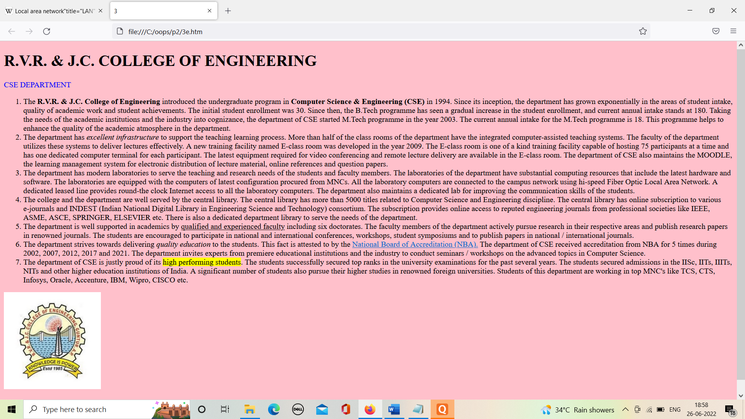

**4.Develop static pages (using only HTML) of an online book store, the pages should resemble: www.amazon.com, the website should consist the following pages, home page, registration and user login, user profile page, books catalog, shopping cart, payment by credit card, order confirmation.**

**THEORY:**

Static web pages are generally simple HTML written pages which serve as response from browser to server in which all the information and data is static in nature and it does not get changed until someone changed it manually.

**SOURCE CODE:**

<html>

<head>

<title>

Amazon</title>

</head>

<body bgcolor="tomato"> <center>

<strong><h1>Welcome to AMAZON</h1></strong>

<form method="post" action="Login.htm" target=_blank >

<h4>for books</h4><input type="submit" value="click here">

</form>

</center>

</body>

</html>

Books catalog

Catalog.html:

<html>

<head>

<title>

books catalog</title>

</head>

<body bgcolor="tomato">

<center><h1>AMAZON</h1></center>

<form method="post" action="Shopping.htm">

<left>

<table>

<tr>

<td><b><h3>frontend books</td>

<td></td></tr>

<tr>

<td></td>

<td><h4>C&Ds</td>

</tr>

<tr>

<td></td>

<td><h4>Ads</td>

</tr>

<tr>

<td></td>

<td><h4>JAVA

</td></tr>

<tr>

<td><b><h3>backend books</td>

<td></td>

</tr>

<tr>

<td></td>

<td><h4>Oracle</td>

</tr>

<tr>

<td></td>

<td><h4>Ms SQL Server

</td></tr>

<tr>

<td></td>

<td><h4>MySql </td>

</tr>

</table>

</h4>

<center>

<b>for buy one of these books

<br>

</b><input type="submit" value="click here">

</center>

</form>

</body>

</html>

Registration and user Login

Login.html:

<html>

<head>

<title>

login</title>

</head>

<body bgcolor="tomato"> <center>

<strong><h1> AMAZON </h1></strong></center>

<right>

<table align="right">

<tr>

<td><h4>user name</td>

<td><input type="text" ></td>

<td></td>

</tr>

<tr>

<td><h4>password</td>

<td><input type="password"></td>

<td></td>

</tr>

<tr>

<td>

<form method="post" action="Catalog.htm" >

<input type="submit" value="submit" >

</form>

</td>

<td>

<form method="post" action="reg.htm" >

<input type="submit" value="register" >

&nbsp;&nbsp;

<input type="reset" value="reset"></form></td>

</tr>

</table>

</body>

</html>

Order Conformation

Ordrconform:

<html>

<head><title>order conformation</title><M/head>

<body bgcolor="tomato">

<center>

<h1><b>BOOK SHOPPING</h1>

<pre><strong>

<b>Your order Is Conformed

</strong></pre>

<h2><b>THANK YOU</h2>

</center>

</body>

</html>

Payment by credit card

Payment.html:

<html>

<head><title>payment</title></head>

<body bgcolor="tomato">

<center><h1>Payment By Credit Card</h1></center>

<form method=post action="Ordrconform.htm">

<br><br><br><br><br>

<table align="center">

<tr>

<td>

<h4>Total Amount</h4></td>

<td><input type="text">

</td>

</tr>

<tr>

<td><h4>Credit Card Number</td>

<td><input type="text"></td>

</tr>

<tr>

<td>

</td>

<td><input type="submit" value=OK>

</td>

</tr>

</table>

</form></body>

</html>

Registration page

reg.html:

<html>

<head>

<title>

login page</title>

</head>

<body bgcolor="tomato">

<center><strong><h1> AMAZON </h1></strong></center>

<form method="post" action="Catalog.htm" >

<right>

<table align="left">

<tr>

<td><h4>user name</td>

<td><input type="text" ></td>

<tr>

<tr>

<td><h4>password</td>

<td><input type="password"></td>

</tr>

<tr>

<td><h4>confirm password</td>

<td><input type="password"></td>

</tr>

<tr>

<option >

<td><h4>male &nbsp;&nbsp;

<input type="radio" name="sex" id="male"></td>

<td><h4>female &nbsp; &nbsp;

<input type="radio" name="sex" id="female" ></td>

</option>

</tr>

<tr>

<td>Address</td>

<td><textarea name="address" rows=5 cols=19>

</textarea>

</td>

<tr>

<td>

<input type="submit" value="submit" ></td>

<td>

<input type="reset" value="reset"></td>

</tr>

</form>

</body>

</html>

Shopping cart

Shopping.html:

<html>

<head><title>shopping cart</title>

</head>

<body bgcolor="tomato">

<center><h1>

Shopping Cart</h1></center>

<br><br><br><br><br>

<table align="center">

<tr>

<td>Text Books</td>

<td>

<select >

<optgroup label="select the book">

<option value="C&Ds">C&Ds

<option value="Ads">Ads

<option value="Java">Java

<option value="Oracle">Oracle

<option value="Ms SQL Server">Ms SQL Server

<option value="MySql">MySql

</optgroup>

</select>

</td></tr>

<tr>

<td>

Quantity</td>

<td>

<input type="text" id="q">

</td></tr>

<tr>

<td></td>

<td>

<form method=post action="Payment.htm">

<input type="submit" value=ok />

</form>

</td></tr>

</table>

<center>

<pre>Cost of one book is"500" + shipping "100"</pre>

</center>

<body>

</html>

Userprofile

userprofile.html

<html>

<head>

<title>

userprofile</title>

</head>

<body bgcolor="tomato"> <center>

<strong><h1>Welcome to AMAZON Online Book Store </h1></strong></center>

Edit your profile here...

<form method="post" action="Catalog.htm" >

<right>

<table align="left">

<tr>

<td><h4>Edit user name</td>

<td><input type="text" ></td>

<tr>

<tr>

<td><h4>Edit password</td>

<td><input type="password"></td>

</tr>

<tr>

<option >

<td><h4>male &nbsp;&nbsp;

<input type="radio" name="sex" id="male"></td>

<td><h4>female &nbsp; &nbsp;

<input type="radio" name="sex" id="female" ></td>

</option>

</tr>

<tr>

<td>Edit Address</td>

<td><textarea name="address" rows=5 cols=19>

</textarea>

</td>

<tr>

<td>

<input type="submit" value="submit" ></td>

</tr>

</form>

</body>

</html>

**OUTPUT:**

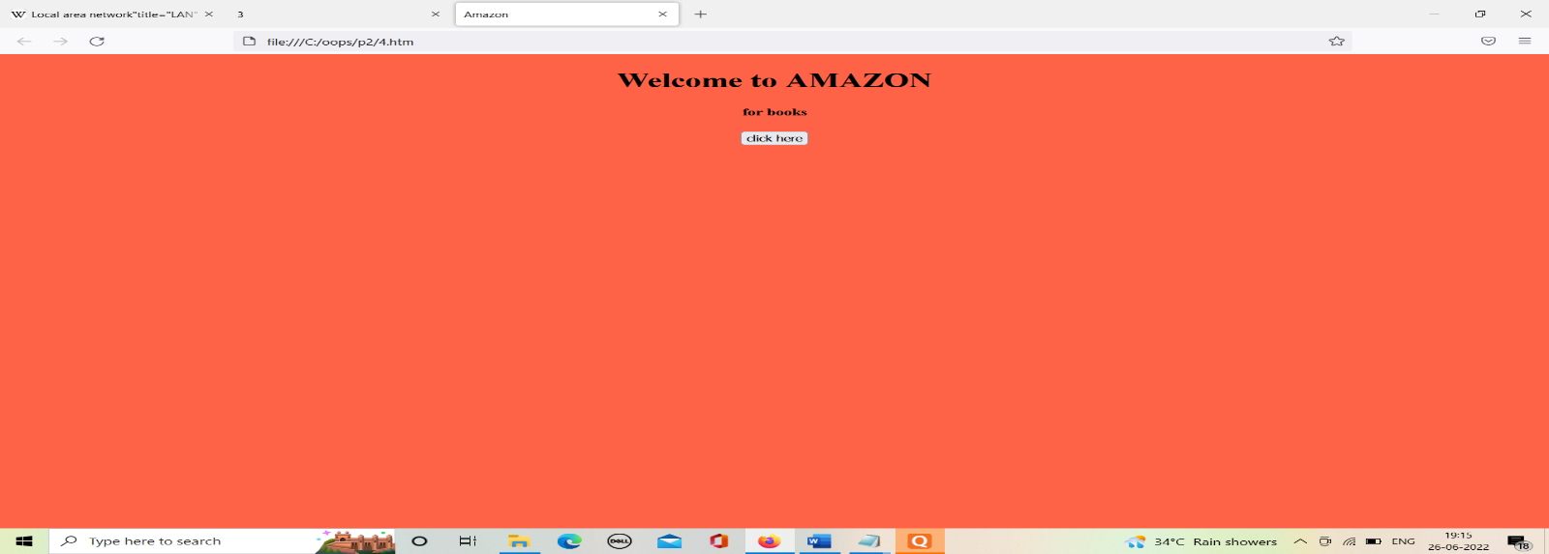

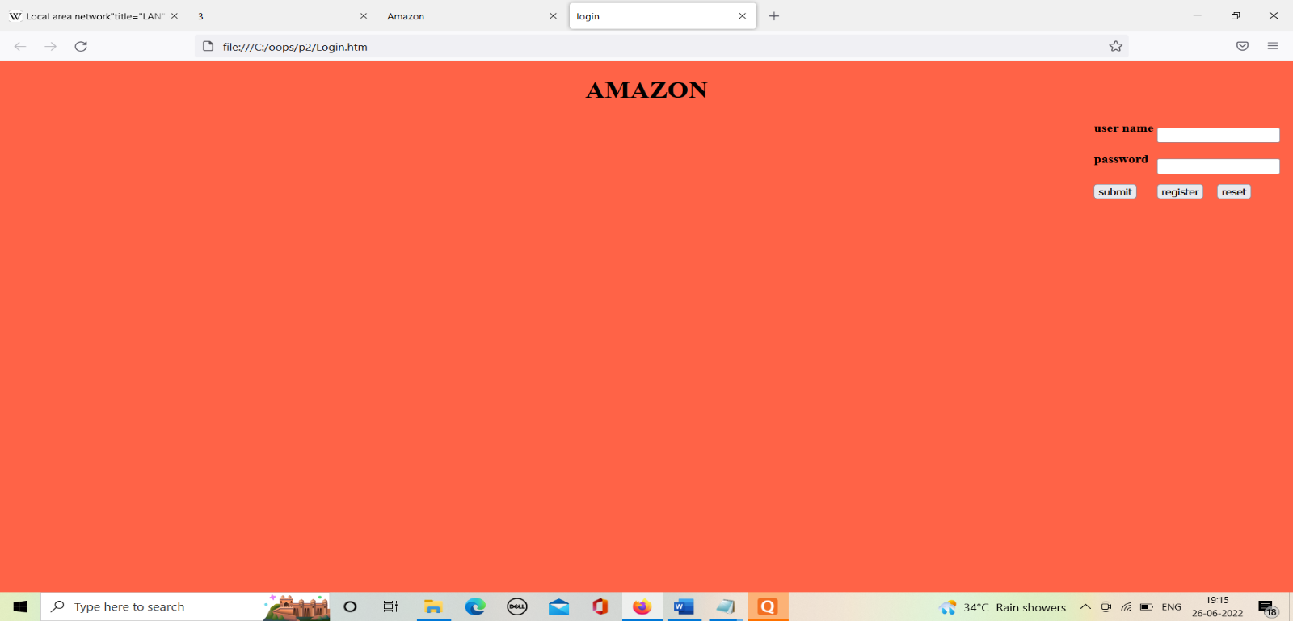

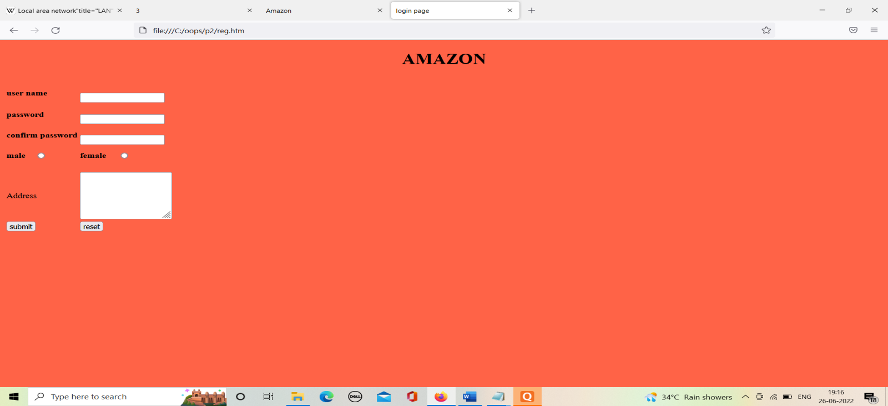

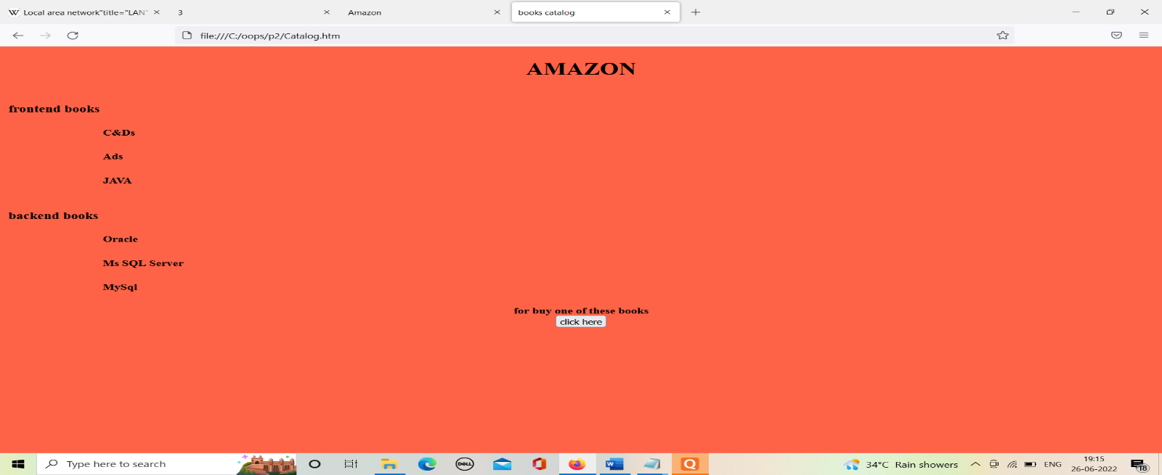

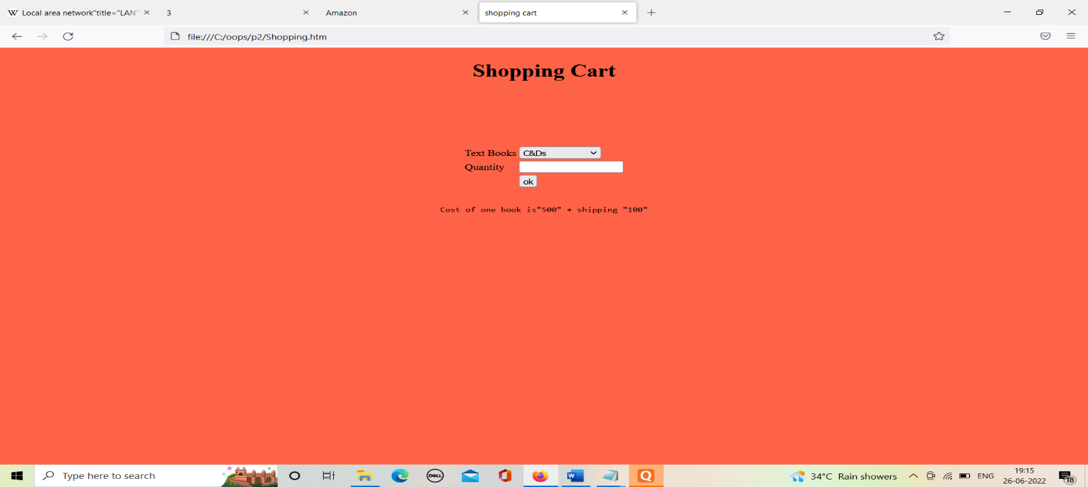

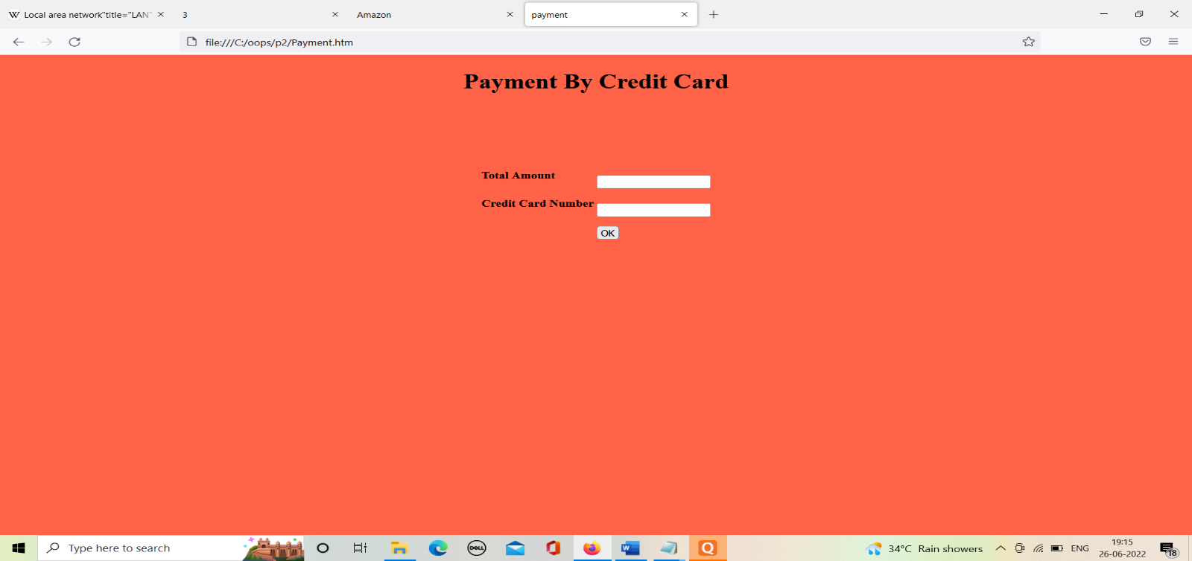

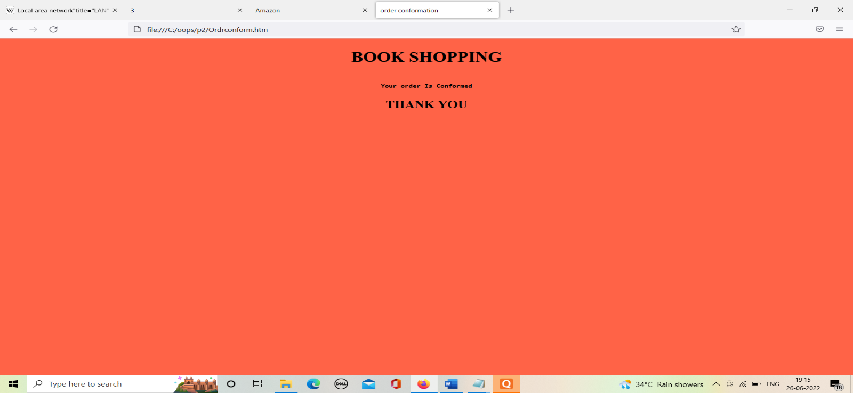

1. **Write an HTML page that contains a selection box with a list of 5 countries, when the user selects a country, its capital should be printed next to the list; Add CSS to customize the properties of the font of the capital (color, bold and font size).**

**THEORY:**

* Cascading Style Sheets (CSS) is used to format the layout of a webpage.
* With CSS, you can control the color, font, the size of text, the spacing between elements, how elements are positioned and laid out, what background images or background colors are to be used, different displays for different devices and screen sizes, and much more!
* Use the HTML style attribute for inline styling
* Use the HTML <style> element to define internal CSS
* Use the HTML <link> element to refer to an external CSS file
* Use the HTML <head> element to store <style> and <link> elements
* Use the CSS color property for text colors
* Use the CSS font-family property for text fonts
* Use the CSS font-size property for text sizes
* Use the CSS border property for borders
* Use the CSS padding property for space inside the border

Use the CSS margin property for space outside the border

**SOURCE CODE:**

<html>

<head>

<title>capitals of countries</title>

<style>

p{

color:blue;

font-weight:bold;

font-size:50;

}

</style>

<script language="javascript">

function capital()

{

var cunt=document.forms["frm1"].country.value;

var capital=" Please select any country ";

if( cunt=="india")

{

capital="NEW DELHI";

}

if( cunt=="china")

{

capital="BEIJING";

}

if( cunt=="u.s.a")

{

capital="Washington";

}

if( cunt=="bangladesh")

{

capital="DHAKA";

}

if( cunt=="japan")

{

capital="TOKYO";

}

if( cunt=="select")

{

capital="Please select any country";

}

document.getElementById("capt").innerHTML=capital;

}

</script>

</head>

<body>

<form name="frm1">

<br/>

<center>

Select a Country : <select name="country" onchange="capital()">

<option value="select">--SELECT--</option>

<option value="india">INDIA</option>

<option value="china">CHINA</option>

<option value="u.s.a">U.S.A</option>

<option value="bangladesh">BANGLADESH</option>

<option value="japan">JAPAN</option>

</select>

<br/>

<br/>

<font color="red" size="6">Capital is :</font> <p id="capt"></p>

</center>

</form>

</body>

</html>

**OUTPUT:**

